Setting up CSS
How to add a standard border to any images inserted using the <img> tag:

Step 1: Download the images, HTML, and CSS files into the same location.
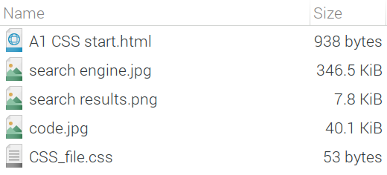

Step 2: Open A1 CSS_file.css in a plain text editor.
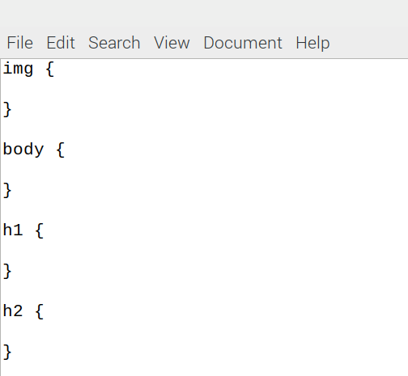

Step 3: Edit the img tag by specifying attributes between the curly brackets.

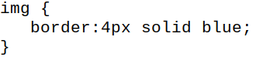

Step 4: Save the CSS file and open the HTML document in a web browser to see the changes applied.

Resources are updated regularly - the latest version is available at: the-cc.io/curriculum.

This resource is licensed by the Raspberry Pi Foundation under a Creative Commons Attribution-NonCommercial-ShareAlike 4.0 International license. To view a copy of this license, visit, see creativecommons.org/licenses/by-nc-sa/4.0/.

